Project Design Phase-II
Technology Stack (Architecture & Stack)

Date | 03 October 2026
Team ID | To be provided
Project Name | Script-Controlled ACL – Restrict Record Access Based on Field Value
Maximum Marks | 4 Marks

Technical Architecture:
The solution is implemented inside a ServiceNow-managed platform. Users access list, form, and optionally Service Portal interfaces; ServiceNow evaluates roles and ACL scripts before exposing records or operations.
Project architecture: identity and role layer → ServiceNow UI → ACL/security layer → u_institution_details data layer.
Reference: ServiceNow platform configuration and ACL documentation; project-specific implementation details are based on the supplied lab file.https://developer.ibm.com/patterns/ai-powered-backend-system-for-order-processing-during-pandemics/
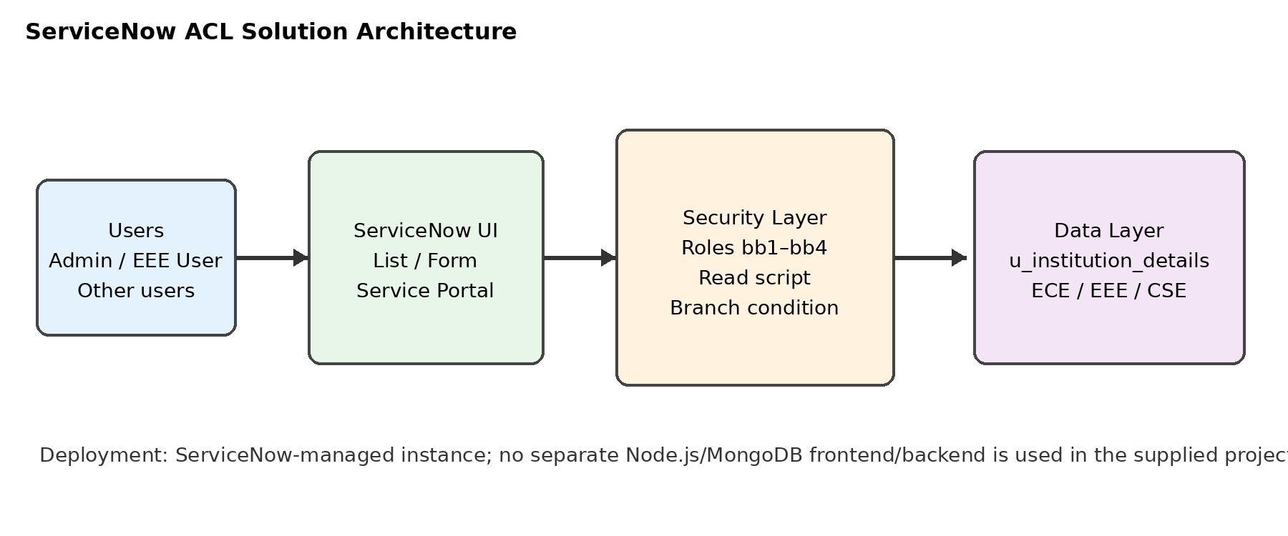
Guidelines:
Include all the processes (As an application logic / Technology Block)
Provide infrastructural demarcation (Local / Cloud)
Indicate external interfaces (third party API’s etc.)
Indicate Data Storage components / services
Indicate interface to machine learning models (if applicable)


Table-1 : Components & Technologies:
S.No | Component | Description | Technology
1. | User Interface | Users interact through ServiceNow list, form, and supported Service Portal views. | ServiceNow UI / Service Portal
2. | Application Logic-1 | Evaluates Read access using administrator override, bb1 role, and Branch = EEE condition. | ServiceNow Advanced Record ACL / GlideSystem
3. | Application Logic-2 | Controls record creation using the bb2 role. | ServiceNow Create ACL
4. | Application Logic-3 | Controls updates and deletion using bb3 and bb4 roles. | ServiceNow Write and Delete ACLs
5. | Database | Stores u_institution_details records and fields including Branch, references, contact data, and Description. | ServiceNow table storage
6. | Cloud Database | The supplied project does not use a separately managed cloud database. | ServiceNow-managed data layer
7. | File Storage | No project file storage is required; screenshots/evidence are maintained separately for testing. | ServiceNow attachments or approved project storage
8. | External API-1 | No external API is specified in the supplied project. | Not applicable
9. | External API-2 | No external API is specified in the supplied project. | Not applicable
10. | Machine Learning Model | No machine-learning model is used; authorization is deterministic. | Not applicable
11. | Infrastructure (Server / Cloud) | Application runs on the organization’s ServiceNow instance; administration requires authorized roles and security_admin elevation. | ServiceNow cloud/managed instance

Table-2: Application Characteristics:
S.No | Characteristics | Description | Technology
1. | Open-Source Frameworks | No external application framework is used in the supplied project. | ServiceNow platform
2. | Security Implementations | Record ACLs, role-based access, advanced script, Branch data condition, security_admin elevation, and least-privilege operation roles. | ServiceNow ACL / GlideSystem
3. | Scalable Architecture | Centralized table ACLs evaluate access consistently as records and users grow; add regression tests and role governance for expansion. | ServiceNow platform controls
4. | Availability | Availability depends on the ServiceNow instance and its configured authentication, platform, and recovery services. | ServiceNow managed availability
5. | Performance | Measure list/form response, filtered records, controlled concurrency, and sustained sessions; avoid unnecessary ACL complexity and validate representative data volumes. | ACL evaluation and platform monitoring

References:
https://c4model.com/ServiceNow product documentation: https://www.servicenow.com/docs/
https://developer.ibm.com/patterns/online-order-processing-system-during-pandemic/Project source document: Script-Controlled ACL – Restrict Record Access Based on Field Value
https://www.ibm.com/cloud/architectureInstance-specific ACL configuration and test evidence: To be attached by project team
https://aws.amazon.com/architecture
https://medium.com/the-internal-startup/how-to-draw-useful-technical-architecture-diagrams-2d20c9fda90d

